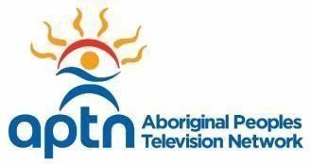

Programming Coordinator- Legal
Are you committed to celebrating and promoting a stronger Indigenous production community?
Are you super organized, love to juggle a variety of tasks, and have a keen eye for the details?
Do you want to play a key part in showcasing distinctive Indigenous content produced by, for and about Indigenous People? If you said YES, then this is the right opportunity for you!

Your opportunity:
- Be part of the Programming team at one of Canada’s Top 100 Employers!
- Interact and support your team members across Canada
- See what really goes on behind the scenes
- Showcase critical thinking skills and eye for accuracy

As our Programming Coordinator-Legal you will:
- Ensure legal contractual compliance
- Review and coordinate the flow of contracts ensuring all required documents are complete and received
- Proofread and edit agreements and letters with independent producers and distributors
- Ensure that all deliverables arrive according to our licence agreement and follow up when overdue
- Provide administrative support for the department including maintaining centralized calendar, agendas and supply inventories

You bring:
- Post-secondary education in legal or business affairs with proven related experience
- A solid understanding of contract law and litigation
- An ability to assess and provide feedback and/or recommendations to ensure that programs content delivers to audience expectations
- Excellent communication, teamwork, attention to detail and strong interpersonal skills
- Proficiency with MS office, email and internet

Your new opportunity awaits, come and see what makes us one of Canada’s top employers! Click here to join our team today Please apply before Wednesday, June 6, 2018.



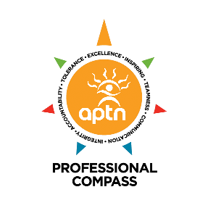

As an Indigenous employer we encourage First Nations, Inuit and Métis applicants to apply.

