4) Your Voice
a) In normal conversation, we communicate not only with the content of what we are saying, but also with a number of physical components that provide the person listening to us with further cues about our emotional state and meaning.
-with your voice:
-tone
-pitch
-volume
-pace
-rhythm
-enunciation
-emphasis

-with your body
-facial expressions
-gestures
-posture

b) Both radio and television eliminate or limit the physical components of conversation.

-In the case of radio, you sit alone in a small room and talk out loud by yourself. The listener can’t see any of the physical cues that add to the telling of your story. Your voice is carried through the equipment and broadcast, and ultimately could be heard by the listener on the 3-inch speaker of his or her clock radio.
-Television fares better in that it carries an image of the physical cues of conversation, but ultimately is less effective because the the image is still two-dimensional.

c) How the voice works

-Remember the first time you heard your voice recorded? You may have been struck by how thin sounded compared to how you hear it normally. That’s because the recording doesn’t capture how we hear ourselves: through our ears, but also through low-frequency vibrations in the bones of our heads and resonance in the sinuses. The sinuses are cavities in the skull.

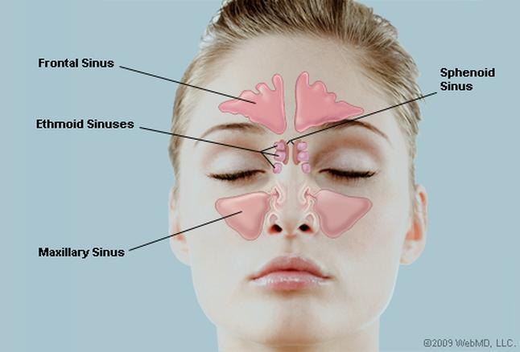

-The voice also resonates in the larynx and in the chest cavity. In effect, you have a column of air that runs from just above your diaphragm to the sinuses. It’s important to keep that column open and unencumbered. You do this two ways:

- posture: Maintain the air column. Stand if you like, or sit straight with your weight on your hips and your back away from the back of the chair. Make sure you aren’t leaning on your elbows; this can push the muscles in your neck in and compress your larynx. Similarly, keep your head up so you don’t push your chin down toward your larynx.
- relaxation: Be aware if there’s any stress or tension, especially in the muscles supporting the column of air. Shrug your shoulders a few times, shake out tension in your arms, roll your head around on your neck.

5) Presence

- Presence is the effect you are trying to create in your performance on the radio or television. It is reaching the listener or viewer in such a way that you are creating a conversation (albeit one-sided) and telling your story in a way that allows that listener to understand it immediately. You achieve presence through three things:

-authority: In most cases, the listener accepts your authority largely because you are with the CBC. Our reputation confers a great deal of authority based on our record of maintaining a high standard of journalistic quality in our news reporting. You also have authority by presenting your reports with confidence and an understanding of the story’s emotional and intellectual content.

-credibility: Credibility also comes with being a CBC journalist. In addition, having a story that is well-researched, well-written and in line with the principles of our journalistic standards, i.e., fair, accurate and balanced.

-authenticity:

a) Authenticity means sounding like you when you broadcast. Too often, journalists don’t trust their voice (both the speaking voice and their voice as storytellers). Broadcast journalists sometimes put on a voice that is their impression of what a journalist should sound like. We shape this impression by watching other journalists and assuming that the story we are telling is somehow better when it’s delivered in an artificial and/or self-important manner.

b) Authenticity comes from two sources.

- Preparation

-Understand the story, both intellectually (its content) and emotionally (how the listener might react to it). Your understanding of the tone of the story will shape your performance of it.

-Read the story aloud, at the level you will perform it, at least twice. By doing this, you’ll hear stumbles as indicators of where the script might need to be rewritten. You will also create muscle memory in the muscles of your face and jaw.

-Relax. Check yourself for tension or stress, especially in your shoulders and neck. Ensure your posture is correct.

2) Understand the “virtual” distance that radio and its technology impose between you and the listener.

-Remember that you are trying to engage the listener and tell her or him your story in a way that it is communicated clearly and concisely on one hearing. But you have to do this while performing in an artificial situation (sitting in a box, by yourself, talking into a microphone) without the benefit of any visual cues (body language, facial expressions, etc.). The technology takes your presence and reduces it to a voice coming out of a 3-inch speaker on someone’s clock radio.

-Assume that the actual physical distance between you and the listener is about three times the usual distance between two people in conversation. To reach across that distance, you don’t have to shout. You do have to speak a little louder, emphasize certain words, enunciate a little more. Your physical cues will be bigger; your gestures a little broader, your facial expressions a little more animated. That’s how you should tell your story.

-keep in mind that you’re trying to create an authentic persona that is you, but is a little larger-than-life. Through practice and listening sessions, you will find the right balance between the two aspects. At first, you may feel you’re going “over the top”. Listening sessions will help you find the right tone.

6) Delivery

- Recreating conversation with the voice only: If you watch two people having a conversation, you might notice that as a person is talking, he or she doesn’t always maintain eye contact with the other person. However, the speaker will make eye contact when coming to the end of a thought. We do this to ascertain the listener’s reaction. That simple physical connection changes the way we talk, as do our facial expressions, posture and gestures. Since radio eliminates those physically-generated visual aspects, we can nevertheless use them to shape our delivery. What follows is a simple method.

- In novels, there are chapters. For our purposes, we will apply chapters to the news stories we are telling. A chapter can be defined by the introduction of a character, a change of action, a change of scene or a new idea.
- Read your script, and decide where each chapter begins and ends. At the end of each chapter, use a black Sharpie to draw a line all the way across the page. (In this exercise, a chapter also ends right before a clip and after your sign-off.)
- Read the first chapter. When you have it, cover the chapter and paraphrase it in the simplest way, out loud. Repeat this with every chapter. By doing so, you are understanding the flow of the story and focussing your intellectual and emotional understanding of it.
- Compare your paraphrased version to the story’s focus. Does it match?
- Read you story aloud, as you would perform it live or to be recorded. While reading it, look up at the listener you have visualized and say the last part of each chapter to the listener, without looking at the script. Trust that your brain and your eyes are working more quickly than your mouth. You will be able to say those last words without reading them. Be aware of the psychological distance between you and the listener.
- The black line serves a number of purposes. It tells you when to look up. It adds a natural pause to the pace of your storytelling. It reminds you that you are telling a story, and not just reading it. It changes you delivery and makes it more natural by adding a physical aspect of conversation. (as do gestures, which you should make if they feel natural.) And it gives you a strong visual cue of where you eye should land.
- Be aware of complex ideas or strong emotional images that the listener may need time to absorb.
- Make sure that you read your completed script out loud at least twice before you perform it for posterity.

